1. What is a constructor?

A constructor is a method in object-oriented programming that initializes a newly-created object.

1. Difference between abstract class and interface

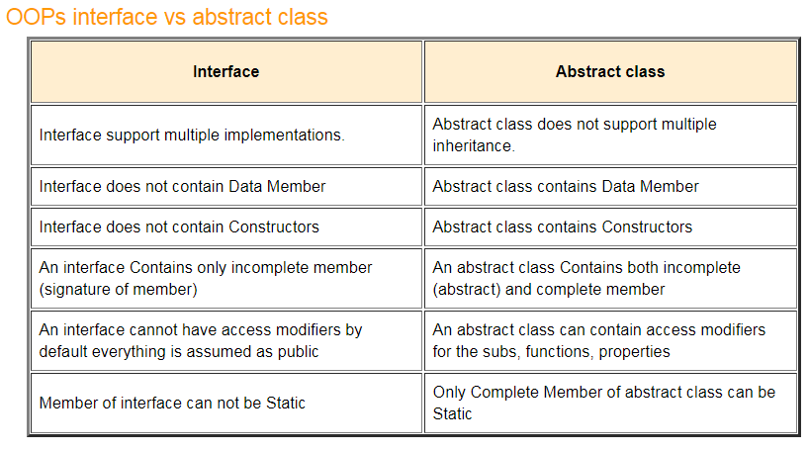

1. What is the use of an interface and an abstract class?

Multiple interfaces can be implemented, but only one abstract class can be inherited. Interface don’t contain fields; abstract classes can. Interfaces do not contain constructors; abstract classes do. Interfaces do not show completed properties (methods); abstract classes can contain either complete or incomplete properties. Neither interfaces nor abstract classes can be instantiated.

1. Types of constructors
   1. Default
   2. Parameterized (at least one parameter)
   3. Copy (initializes object to the values of an existing object)
   4. Static - When a constructor is created using a static keyword, it will be invoked only once for all of the instances of the class and it is invoked during the creation of the first instance of the class or the first reference to a static member in the class. A static constructor is used to initialize static fields of the class and to write the code that needs to be executed only once.
      1. A static constructor does not take access modifiers or have parameters.
      2. A static constructor is called automatically to initialize the class before the first instance is created or any static members are referenced.
      3. A static constructor cannot be called directly.
      4. The user has no control over when the static constructor is executed in the program.
      5. A typical use of static constructors is when the class is using a log file and the constructor is used to write entries to this file.
2. What are Access modifiers?

Used to set the level of accessibility of classes, methods, and other members (e.g., private, protected, and public)

1. What is static and its use?

Declares a member of a type so that it is specific to that type

* 1. Class-level, not object-level
  2. Cannot be instantiated

1. How would you write a constructor?
   1. A constructor’s name must be the same as its class name
   2. Cannot have a return type
   3. Parameters are optional
   4. Overriding is allowed, but not multiple constructors with the same signature
2. What is a Primary Key?

A special relational database table column (or combination of columns) used to uniquely identify a table record

1. What is a Foreign Key?

A column in one table that points to unique values in another (usually the primary key)

1. If you have two tables Employee(columns: id and name) and Department(columns: id and name), how would you use the primary and foreign keys to join them?

One department has multiple employees, so a foreign key would be added to Employee to assign the department id, which matches an id in the Department table.

1. What is a left join?

Returns all rows from the left table to the matchings rows on the right table

1. What is a clustered and non-clustered index?

Clustered indices sort and store data based on their key values. A non-clustered index is an index where the order of the rows do not match the physical order of the actual data.

1. Write a query that returns the third highest salary from a table

SELECT column FROM table ORDER BY column DESC LIMIT 2,1;

1. What is a view state?

A view state is like a session state but for a specific page. It preserves the value of a page and controls round-trip.

1. Different view state management techniques
   1. Client-Side State Management Techniques - To maintain the state of values on the client’s machine, we use the client-side state management techniques
   2. Server-Side State Management Techniques - To maintain the state of values on the server’s machine, we use the server-side state management techniques
2. How would you achieve input validation in ASP.NET?

<https://docs.microsoft.com/en-us/aspnet/web-pages/overview/ui-layouts-and-themes/validating-user-input-in-aspnet-web-pages-sites>

1. What are the names of components in Angular?

<https://angular.io/guide/component-overview>

* 1. An HTML template that declares what renders on the page
  2. A TypeScript class that defines behavior
  3. A CSS selector that defines how the component is used in a template
  4. Optionally, CSS styles applied to the template

1. What is bootstrap?

<https://www.w3schools.com/whatis/whatis_bootstrap.asp>

Bootstrap is the most popular CSS Framework for developing responsive and mobile-first websites.

1. Can you use access modifiers in an interface?

No. It’s all public and meant to be.

1. Array vs ArrayList
   1. An array is a fixed-length data structure. ArrayList is a variable-length data structure. It can be resized itself when needed. It is mandatory to provide the size of an array while initializing it directly or indirectly.
   2. ArrayList is a class belonging to the Collection framework.
2. What is JIT?

Just-In-Time compiler(JIT) is a part of Common Language Runtime (CLR) in .NET which is responsible for managing the execution of .NET programs regardless of any .NET programming language. A language-specific compiler converts the source code to the intermediate language. This intermediate language is then converted into the machine code by the Just-In-Time (JIT) compiler. This machine code is specific to the computer environment that the JIT compiler runs on.

1. What is the difference between primary and foreign key? (wanted me to expand on that a lot)

Primary keys are unique and identify a row in a table. Foreign keys point to a column in another table, usually a Primary key. This can be used to assign a 1-to-many relationship such as Department and Employee.

1. Difference between boxing and unboxing

Boxing converts a value type to a reference (object) type and unboxing does the reverse.

1. How to assign a data type? Object?

Object myObject = new Object();

Car myCar = new Car();

1. How did you use entity framework methods?
2. How did you communicate with database?
3. What is unmanaged code?

Managed code is executed by the CLR (Common Language Runtime) while unmanaged code is executed by the operating system.

1. Difference between .NET core and .NET framework

.NET Core is used to create server applications that run on Windows, Linux, and Mac. .NET Framework is used to create Windows desktop and server-based application, including ASP.NET web applications.

1. Tell me about your history in IT
2. Inheritance

Inheritance allows for the creation of a new class based on an existing class.

1. SOLID principles
   1. S: Single Responsibility Principle (SRP) - Every software module should have only one reason to change (one job)
   2. O: Open/Closed Principle - A software module/class is open for extension and closed for modification
   3. L: Liskov Substitution Principle - You should be able to use any derived class instead of a parent class and have it behave in the same manner without modification
   4. I: Interface Segregation Principle (ISP) - Clients should not be forced to implement interfaces they don't use. Instead of one fat interface, many small interfaces are preferred based on groups of methods, each one serving one submodule.
   5. D: Dependency Inversion Principle - High-level modules/classes should not depend on low-level modules/classes. Both should depend upon abstractions. Secondly, abstractions should not depend upon details. Details should depend upon abstractions.
2. SQL indexes

Pointer to a table, used to speed up data retrieval

1. SQL functions
   1. AVG() - Returns the average value.
   2. COUNT() - Returns the number of rows.
   3. FIRST() - Returns the first value.
   4. LAST() - Returns the last value.
   5. MAX() - Returns the largest value.
   6. MIN() - Returns the smallest value.
   7. SUM() - Returns the sum.
2. Method overloading

A method with the same name as another, but with a different signature so the application knows which one to execute

1. Method overriding

Runtime polymorphism concept where a child class has a method with the same signature as its parent, with the purpose of having a unique implementation.

1. Polymorphism

Allows for the interpretation of different objects based on their class or data type. Many classes related to each other based on inheritance is an example of polymorphism, such as a Car class that inherits from an Automobile class.

1. Multiple inheritance

In C#, a class may implement multiple interfaces, but can only

1. Normalizations
   1. 1NF – Only single values permitted (no repeated groups)
   2. 2NF – Must be 1NF and the primary key be a single attribute
      1. If the relation has a composite PK, then each non-key attribute must be fully dependent on the entire PK and not on a subset of the PK (i.e., there must be no partial dependency or augmentation).
   3. 3NF – Must be in 2NF plus all transitive properties removed. That is, no non-key attribute should be dependent on another.
   4. 4NF – No multivalued dependencies other than candidate key
   5. BCNF (Boyce-Codd Normal Form) – There shouldn’t be a way to create more than one candidate key. Removing this puts it in BCNF.
2. SQL views

Virtual tables based on the result-set of an SQL statement

1. SQL joins

Combines rows from two or more tables based on a commonality

1. Catch block questions

Catches a thrown exception such as ArithmeticException

1. What is Entity Framework?

Entity Framework is an open-source [ORM framework](https://en.wikipedia.org/wiki/Object-relational_mapping) for .NET applications supported by Microsoft. It enables developers to work with data using objects of domain specific classes without focusing on the underlying database tables and columns where this data is stored. With the Entity Framework, developers can work at a higher level of abstraction when they deal with data, and can create and maintain data-oriented applications with less code compared with traditional applications.

1. Your name and what were the last projects you worked on?
2. What kind of SQL did you use?

Microsoft Server SQL Management Studio

1. Why would you want to use PostGreSQL for store project?

PostgreSQL is an open source database released under the PostgreSQL License, an Open Source Initiative Approved License. The use of PostgreSQL for any purpose, including commercial, is free. Under the PostgreSQL Global Development Group, PostgreSQL is available as free and open source software in perpetuity.

1. SQL - Standard Query Language – Used to perform database operations. Includes:
   1. DDL – Data Definition Language – Defines database schema
   2. DQL – Data Query Language – Performs queries within schema objects
   3. DML – Data Manipulation Language – Manipulation of data within the database
   4. DCL – Data Control Language – Used to manipulate permissions
2. SQL index

The key(s) based on one or more column

1. How would you update a database through C#?
   1. Create an SqlConnection initialized with a connection string.
   2. Create an SqlCommand, passing in an SQL statement in a string, followed by the SqlConnection as the second parameter.
   3. Substitute the appropriate parameters within the string with the variables
   4. Execute the scalar from the SqlCommand using ExecuteNonQuery().

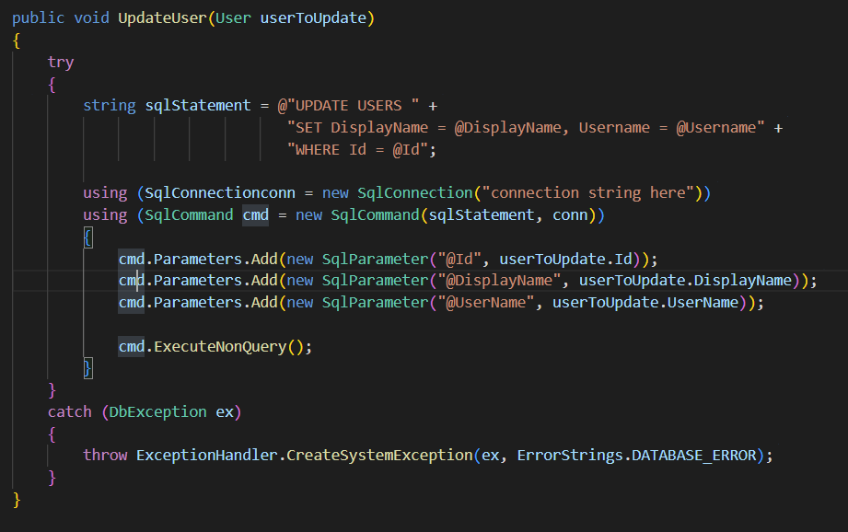

1. The difference b/w delete, truncate, and drop
   1. Delete – deletes one or more rows within a table
   2. Truncate – removes all the rows from within a table faster than using the delete command to do the same thing
   3. Drop – deletes an entire table, not just the values within them
2. What is rollback and have you used it?

A rollback returns software to a previous version

1. What is AOT?

In computer science, ahead-of-time compilation (AOT compilation) is the act of compiling an (often) higher-level programming language into an (often) lower-level language before execution of a program, usually at build-time, to reduce the amount of work needed to be performed at run time.

1. What is and how do you use ADO.NET?

ActiveX Data Objects - ADO.NET is a set of classes that expose data access services for . NET Framework programmers. ADO.NET provides a rich set of components for creating distributed, data-sharing applications. It is an integral part of the . NET Framework, providing access to relational, XML, and application data.

1. MVC and how does it work?

Model–view–controller is a software architectural pattern commonly used for developing user interfaces that divide the related program logic into three interconnected elements. This is done to separate internal representations of information from the ways information is presented to and accepted from the user.

1. Partial view and have you used it

A partial view is a Razor markup file ( . cshtml ) without an @page directive that renders HTML output within another markup file's rendered output. The term partial view is used when developing either an MVC app, where markup files are called views, or a Razor Pages app, where markup files are called pages

1. Angular Model, components, servers, and how you use them in a project

Angular is a platform and framework for building single-page client applications using HTML and TypeScript. Angular is written in TypeScript. It implements core and optional functionality as a set of TypeScript libraries that you import into your applications.

1. What framework did you use to connect the database to C#? (Interviewer did not accept EF Framework)

A .NET Framework data provider is used for connecting to a database, executing commands, and retrieving results.

1. How did you use Kubernetes with Azure?

Kubernetes, also known as K8s, is an open source system for managing containerized applications across multiple hosts. It provides basic mechanisms for deployment, maintenance, and scaling of applications.

Kubernetes builds upon a decade and a half of experience at Google running production workloads at scale using a system called Borg, combined with best-of-breed ideas and practices from the community.

Kubernetes is hosted by the Cloud Native Computing Foundation (CNCF). If your company wants to help shape the evolution of technologies that are container-packaged, dynamically scheduled, and microservices-oriented, consider joining the CNCF. For details about who's involved and how Kubernetes plays a role, read the CNCF announcement.

1. What do you do to get data from an API in Cacophony?
2. Tell me about CICD and how you have used them in projects

Github uses this. It’s for collaboration on projects.

<https://about.gitlab.com/topics/ci-cd/>

1. GIT command lines

<https://confluence.atlassian.com/bitbucketserver/basic-git-commands-776639767.html>

* 1. Initial setup on a machine:
     1. git config -global user.name “[name]”
     2. git config -global user.email “[email address]”
  2. Adding Github repo locally
     1. git clone [URL of repo]
  3. Fetching latest
     1. git pull
  4. Adding/changing
     1. git add [file/directory]
     2. git commit -m “Message”
     3. git push

1. Have you tested in Angular, and how?
2. What is REST?

A REST API (also known as RESTful API) is an application programming interface (API or web API) that conforms to the constraints of REST architectural style and allows for interaction with RESTful web services. REST stands for representational state transfer and was created by computer scientist Roy Fielding.

1. How many people did you work with in each project?
2. Tell me about inheritance in C#

Interfaces, abstract classes, and classes can be inherited. A class can only inherit one class, but can inherit any number of interfaces.

1. Difference between abstract class and virtual?

In abstract classes, methods must be overridden. In virtual classes, it’s optional.

1. Best practices for exception handling?
2. Can you have multiple catch blocks?

Yes. It’s not usually good practice to catch a general Exception, but rather each type of exception that can happen (e.g., DivideByZeroException, FormatException, and OverflowException when attempting to parse a user input into a number and then using it).

1. Difference between constant and readonly?
   1. In C#, a const keyword is used to declare constant fields and constant local. The value of the constant field is the same throughout the program or in other words, once the constant field is assigned the value of this field is not be changed. In C#, constant fields and locals are not variables, a constant is a number, string, null reference, boolean values.
   2. In C#, you can use a readonly keyword to declare a readonly variable. This readonly keyword shows that you can assign the variable only when you declare a variable or in a constructor of the same class in which it is declared.
2. Can you have multiple constructors in C#?
   1. Yes, but they must be overloaded (no two can have the same signature).
3. What are some events in ASP.NET (i.e., its lifecycle)?

<https://docs.microsoft.com/en-us/previous-versions/aspnet/ms178472(v=vs.100)>

1. Tell me about garbage collection

Garbage collection (GC) is a memory recovery feature built into programming languages such as C# and Java. A GC-enabled programming language includes one or more garbage collectors (GC engines) that automatically free up memory space that has been allocated to objects no longer needed by the program.

1. What happens when you compile code in C#?

<https://www.geeksforgeeks.org/how-c-sharp-code-gets-compiled-and-executed/>

1. What is assembly in C#?

An Assembly is a basic building block of . Net Framework applications. It is basically a compiled code that can be executed by the CLR. An assembly is a collection of types and resources that are built to work together and form a logical unit of functionality.

1. Write a code down on paper that will take an input list, count how many times an elemenyt appears in that list, and then output ONLY the elements that appear more than once, including the count itself.
2. Write an SQL query on paper that will read from a table named User with columns “username” and “userid” and return another table with columns “username” and “username count” to count how many times a username appears in a table.
3. How do you create a data access layer using Entity Framework?

<https://blog.magnusmontin.net/2013/05/30/generic-dal-using-entity-framework/#:~:text=Start%20by%20creating%20a%20new,be%20included%20in%20the%20model>.

1. How do you create database objects?

CREATE TABLE [database_name.][schema_name.]table_name (

pk_column data_type PRIMARY KEY,

column_1 data_type NOT NULL,

column_2 data_type,

...,

table_constraints

);

1. What does migration do?

The Migrations feature enables you to change the data model and deploy your changes to production by updating the database schema without having to drop and re-create the database.

1. Tell me about yourself
2. What is the order of the CSS box model?

In CSS, the term "box model" is used when talking about design and layout. The CSS box model is essentially a box that wraps around every HTML element. It consists of: margins, borders, padding, and the actual content. The image below illustrates the box model:

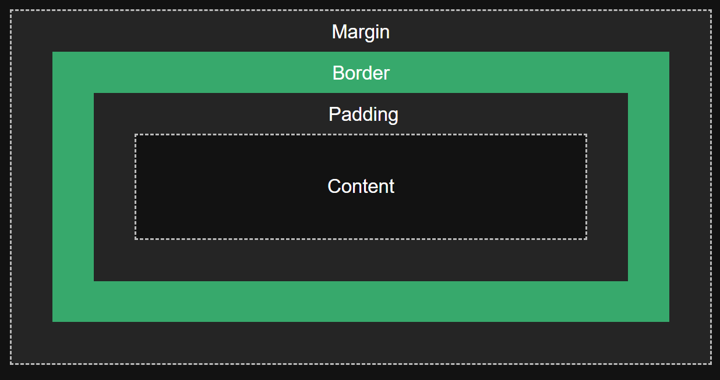

1. How would you add a link in HTML?

<a href=”[url]”>The link’s message here</a>

1. How would you add an image that opens a new window when clicked?

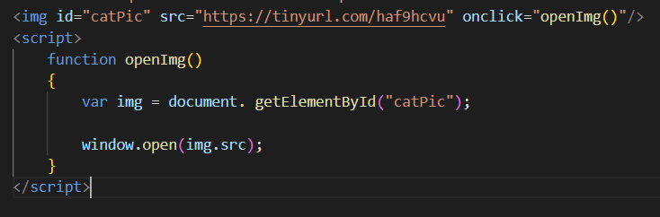

1. What are arrow functions in Angular?

Fat arrow notations are used for anonymous functions i.e for function expressions. They are also called lambda functions in other languages. Using fat arrow =>, we dropped the need to use the function keyword. Parameters are passed in the parenthesis (), and the function expression is enclosed within the curly brackets { }.

1. What are modules in Angular?

In Angular, a module is a mechanism to group components, directives, pipes and services that are related, in such a way that can be combined with other modules to create an application. An Angular application can be thought of as a puzzle where each piece (or each module) is needed to be able to see the full picture.

1. What are services in Angular?

Simply put, services in Angular let you define code or functionalities that are then accessible and reusable in many other components in your Angular project. Services help you with the abstraction of logic and data that is hosted independently but can be shared across other components.

1. What are observables in Angular?

Observable in Angular is a feature that provides support for delivering messages between different parts of your single-page application. This feature is frequently used in Angular because it is responsible for handling multiple values, asynchronous programming in Javascript, and also event handling processes.

1. How would you implement a button that hides paragraphs when clicked?
   1. Assign the same class name to every <p> element
   2. Call a Javascript function for a button when it is clicked
   3. Within the function, grab the elements by class name and iterate through each one, setting the .style.display to ‘none’.

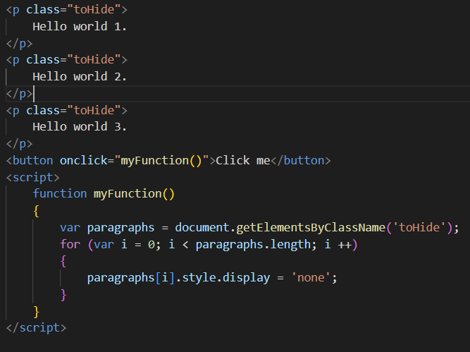

1. What’s the difference between Javascript and Typescript?
   1. TypeScript is an object-oriented programming language developed by Microsoft Corporation, whereas JavaScript is the programming language for the web. TypeScript is an open-source language to build large-scale web apps, whereas JavaScript is a server-side programming language that helps to develop interactive web pages.
   2. Typescript is object-oriented. Javascript is not.
2. What is the name of things like nglf/ngFor/ngSwitch?

<https://angular.io/>

* 1. nglf - A structural directive that conditionally includes a template based on the value of an expression coerced to Boolean. When the expression evaluates to true, Angular renders the template provided in a then clause, and when false or null, Angular renders the template provided in an optional else clause. The default template for the else clause is blank.
  2. nfFor - The core directive ngFor allows us to build data presentation lists and tables in our HTML templates.
  3. The [ngSwitch] directive on a container specifies an expression to match against. The expressions to match are provided by ngSwitchCase directives on views within the container.

1. Name and explain different positions and properties
   1. Position
      1. static
      2. relative
      3. fixed
      4. absolute
      5. sticky
   2. Properties
      1. text
      2. list
      3. border
      4. font

<https://www.freecodecamp.org/news/css-position-property-explained/>

1. What is encapsulation?

Encapsulation is data hiding. Every field and property should be restricted to the access that’s needed and nothing more.

1. How would you use encapsulation?

Fields should be made private and manipulated through getter and setter methods. Everything else should be made as private as possible, restricted to the access needed.

1. What is a viewbag?

A way to pass data from a controller to a view

1. What’s the difference between private and protected?

A private field can only be used within the class. A protected field can be used from within the class or classes that inherit from it.

1. What are partial views and when would you use one?
2. Name the kinds of joins in SQL
   1. inner – combines rows of matching values in two or more tables
   2. outer
      1. left – returns all rows from the left table and matching rows from the right
      2. right – returns all rows of the right table and matching rows from the left
   3. self – joins the table with itself to allow for the comparison of rows
   4. cross – creates a result table containing paired combination of each row of the first table with each row of the second table
3. What’s the difference between a left and right join?
4. Write a query that deleted a specific user

DELETE FROM [table name] where CONDITION

delete from [table] where username = “[username]”;

1. Talk about a project where you used C#
2. What are ref and out?

ref is used to state that the parameter passed may be modified by the method. in is used to state that the parameter passed cannot be modified by the method. out is used to state that the parameter passed must be modified by the method

1. How do you create something in SQL?

create database

create table

1. Types of indices in SQL

clustered – table records are sorted to match an index

non-clustered – logical order of index does not match stored order

1. Did you use LinQ to query the database? What’s another method to do this?

Language-Integrated Query (LINQ) is the name for a set of technologies based on the integration of query capabilities directly into the C# language. Traditionally, queries against data are expressed as simple strings without type checking at compile time or IntelliSense support. Furthermore, you have to learn a different query language for each type of data source: SQL databases, XML documents, various Web services, and so on. With LINQ, a query is a first-class language construct, just like classes, methods, events.

1. Which do you prefer first – code or database?
2. What are some exceptions or issues you’ve faced and how did you resolve them?
3. How would you get data from a controller to a view?

At the end of an ActionResult method, use:

return View([item]);

“item” is what you want returned, such as an Object